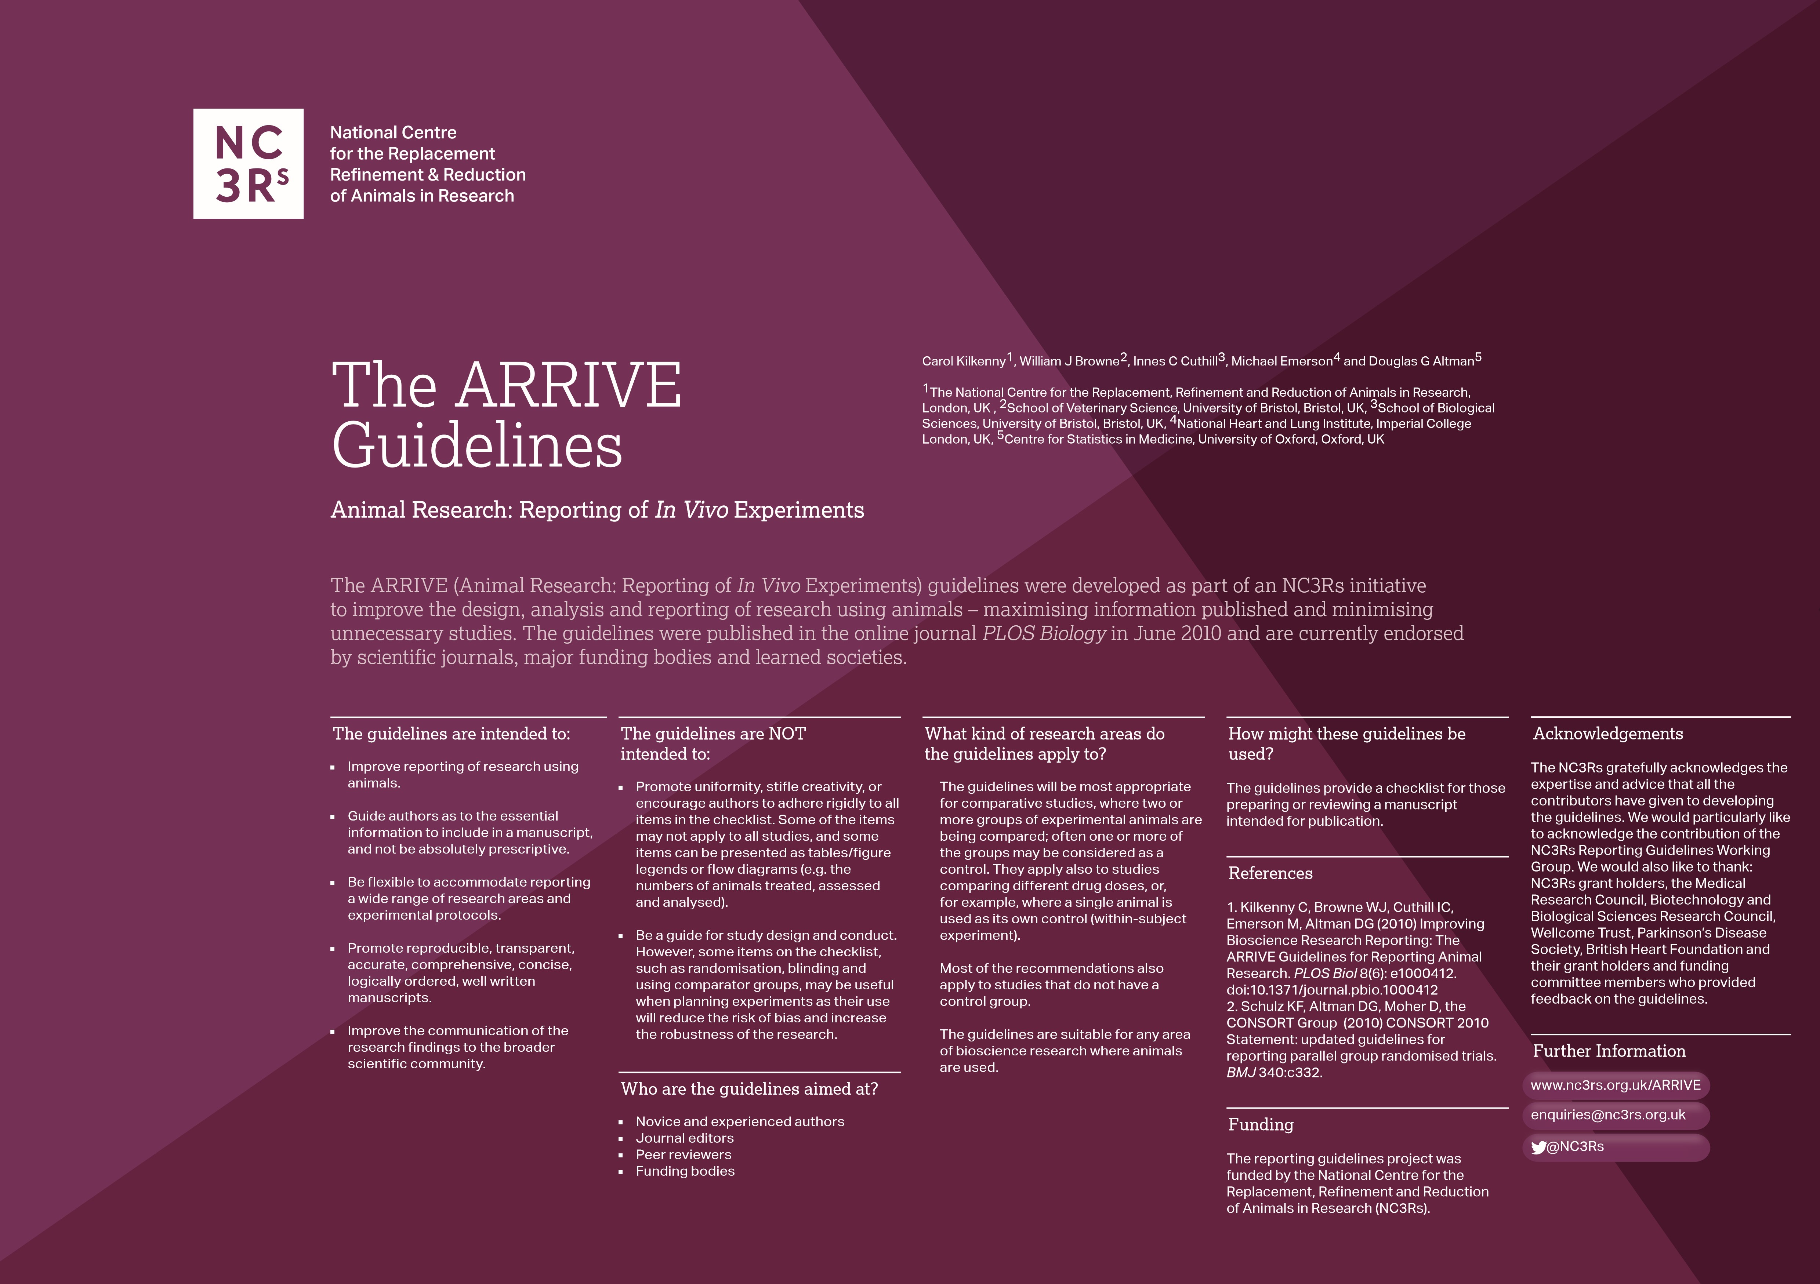
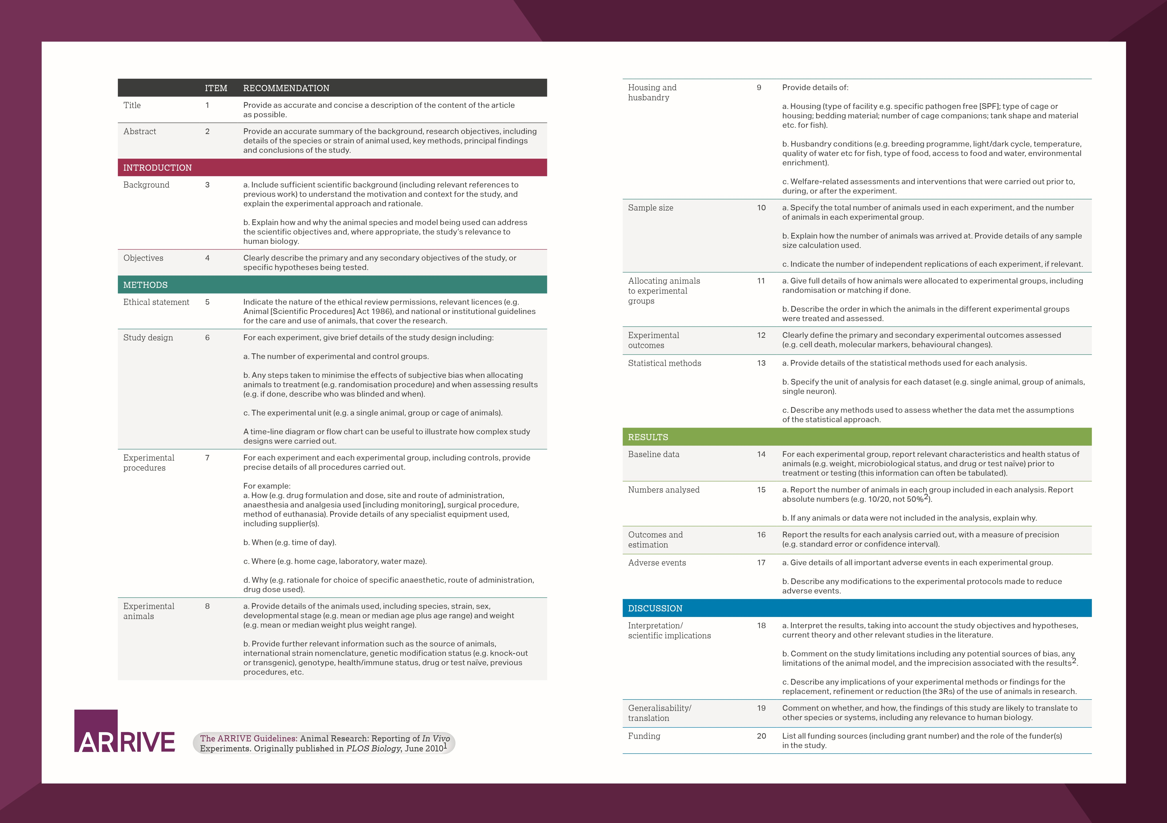
We don’t have any adverse event
paragraph 1, result
Methods, paragraph 1
Line 86
The first paragraph
Line 303
Line 255
Line 321
Figure 1, 2, 3
Methods, paragraph 8
Methods, paragraph 6 and 7
Methods, paragraph 3
Line 97
Methods, paragraph 3
Methods, paragraph 1
Line 81
Paragraph 1
Line 107
Paragraph 4
Line 96
Paragraph 3
Line 86
The last paragraph in introduction
Line 57 and 64
Line 60
Yes
Yes

